GT Online Graduation
Thursday 26th November 2026
Beasley Hall, Perth Modern School
10am – 12pm

Year 7-9 students in GT Online shirts
Year 10 students in smart casual wear

For any parents in Perth, you are most welcome to attend the ceremony.
Please sign in at Perth Modern School Reception
Entry off Roberts Rd, Subiaco

Limited parking in Reception Visitor Bays or street parking Hamilton St or Subiaco Rd

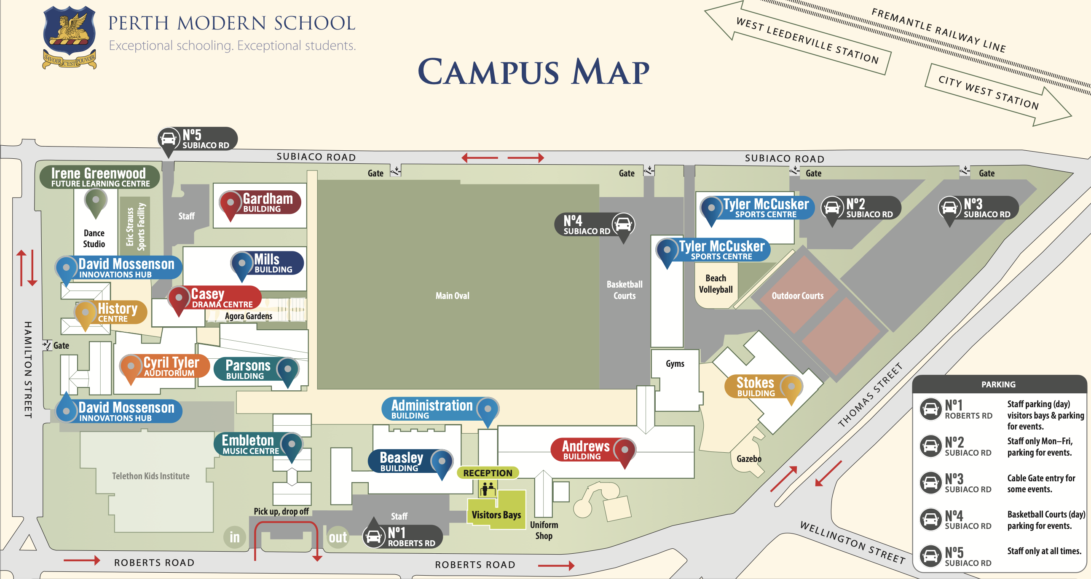

Acknowledgement of Country
Welcome special guests including parents, teachers, students

Program Coordinator Address
Pin presentation for midyear intake and Year 7 students

Learning Area Teacher/s to present Competition Awards and acknowledge success

Acknowledgement of year 7 – 9 departing students
Farewell and introduction of teachers

Farewell to Year 10 students
Presentation of Graduation Certificates and gift + booklet

Photo Slideshow Year 10’s
Year 10 Speech/s and Farewell Performance
A message to the graduating class

